Project Demonstration

Date | 07/07/2026
Team ID | SWTID-2026-9649
Project Name | Sports Hall Booking System by Service Portal(ServiceNow)

1. Project Objective
The Sports Hall Booking System is developed using the ServiceNow Service Portal to automate sports hall reservations. The system allows users to view available sports halls, book preferred time slots, receive booking confirmations, and manage reservations. Administrators can efficiently manage bookings while reducing manual work through automation.
Table and fields Creation
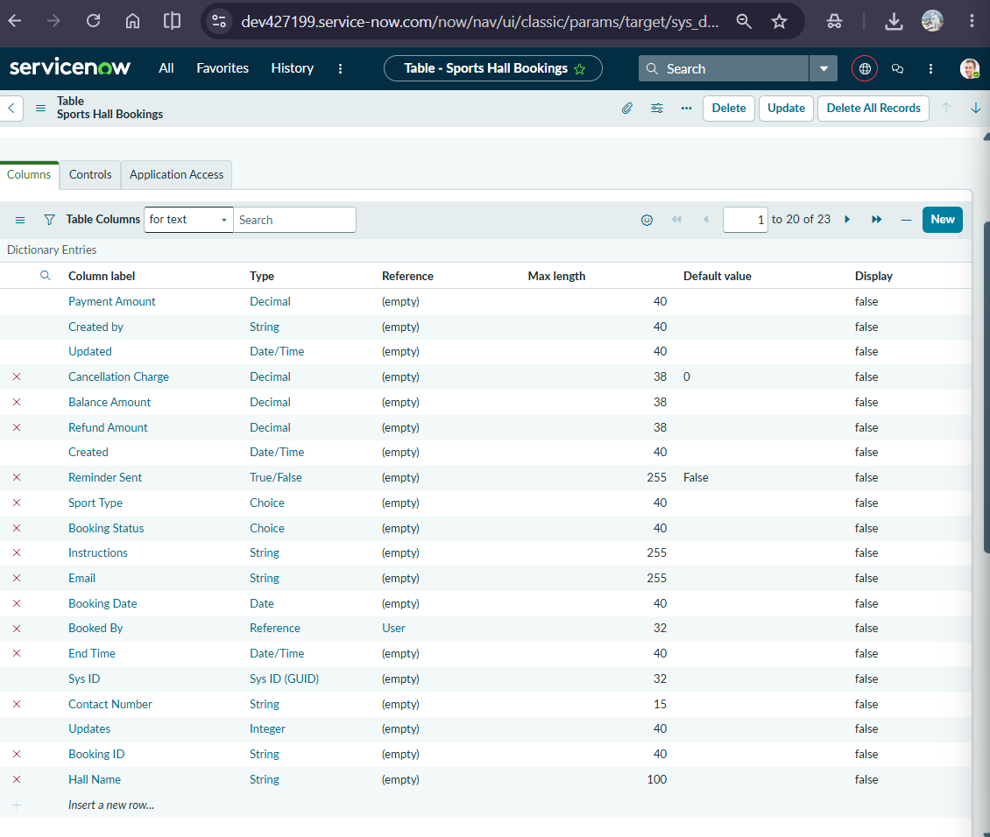

Schedule Job
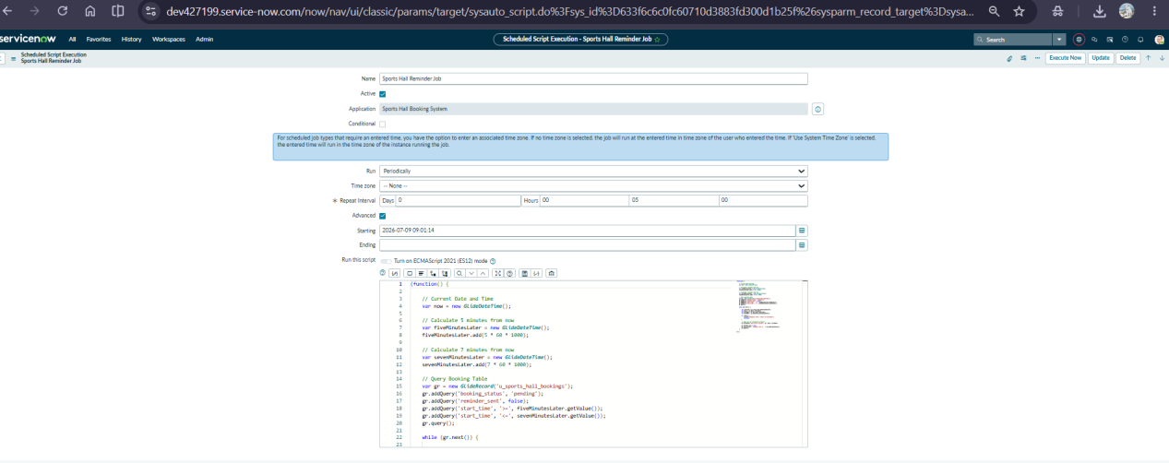

Business Rule

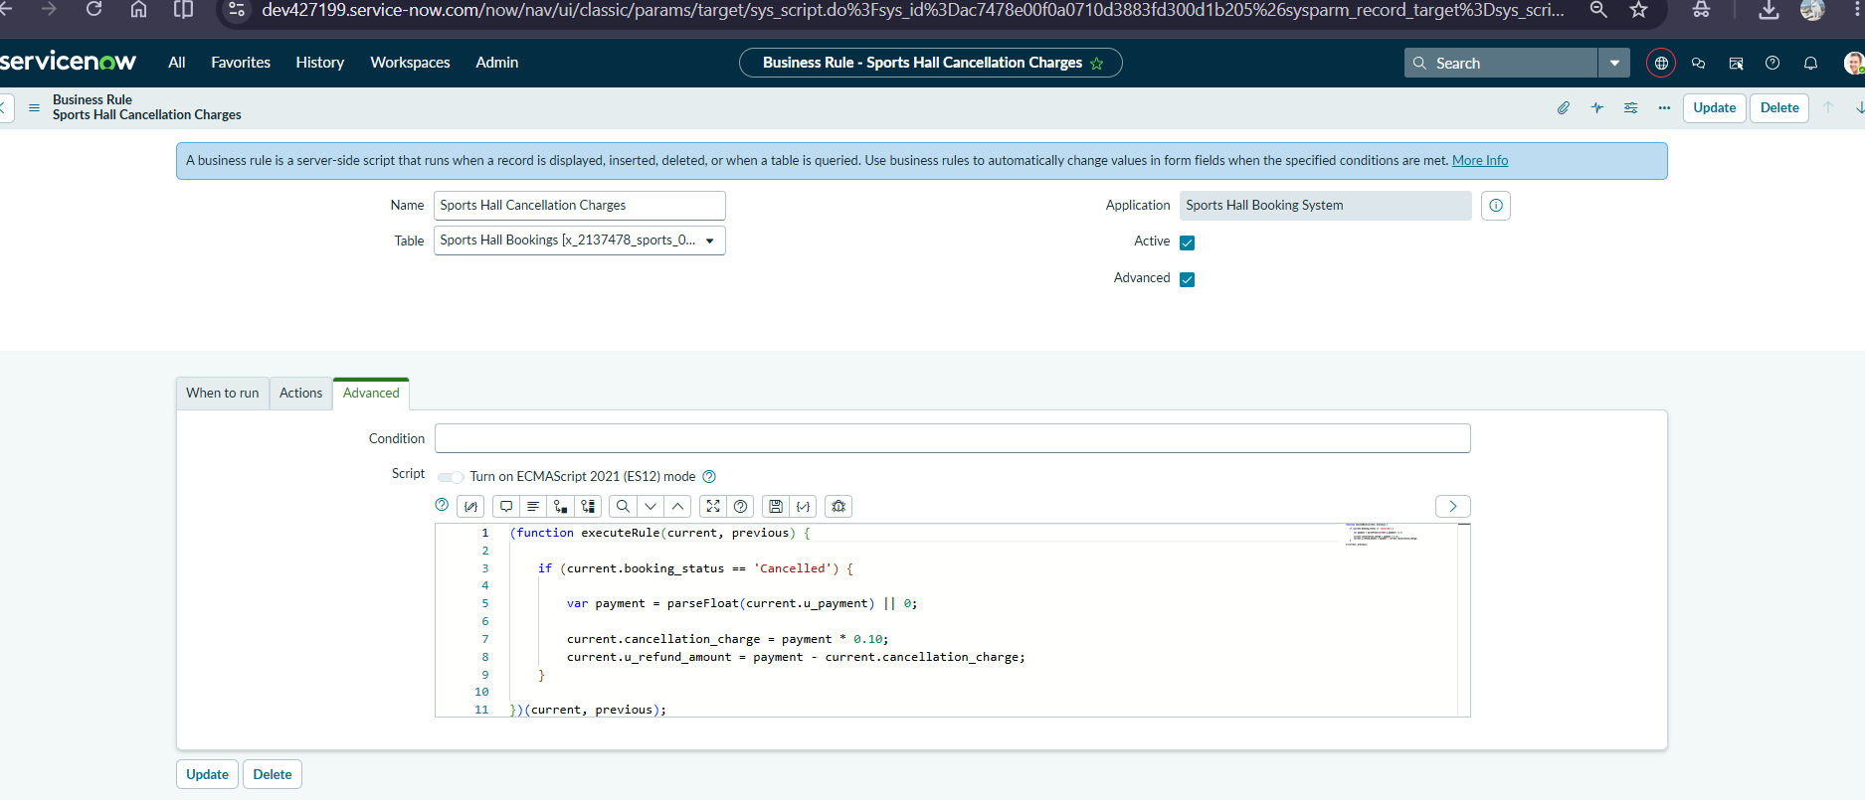

Service Portal (Sports Zone)

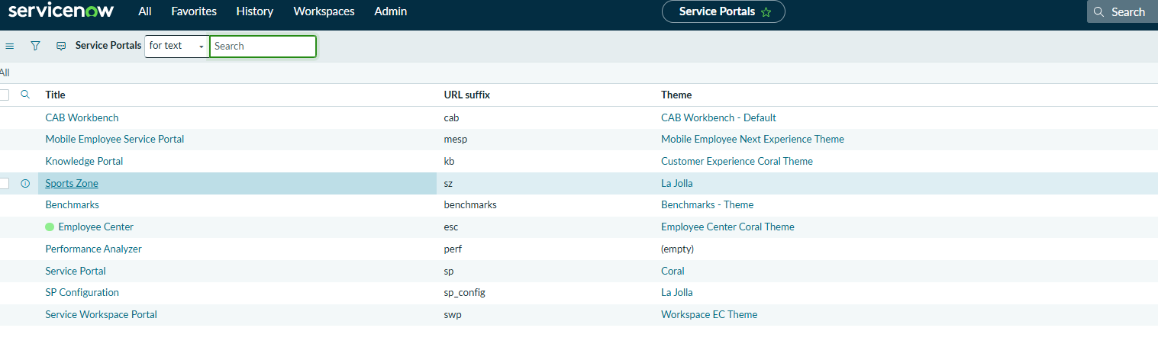

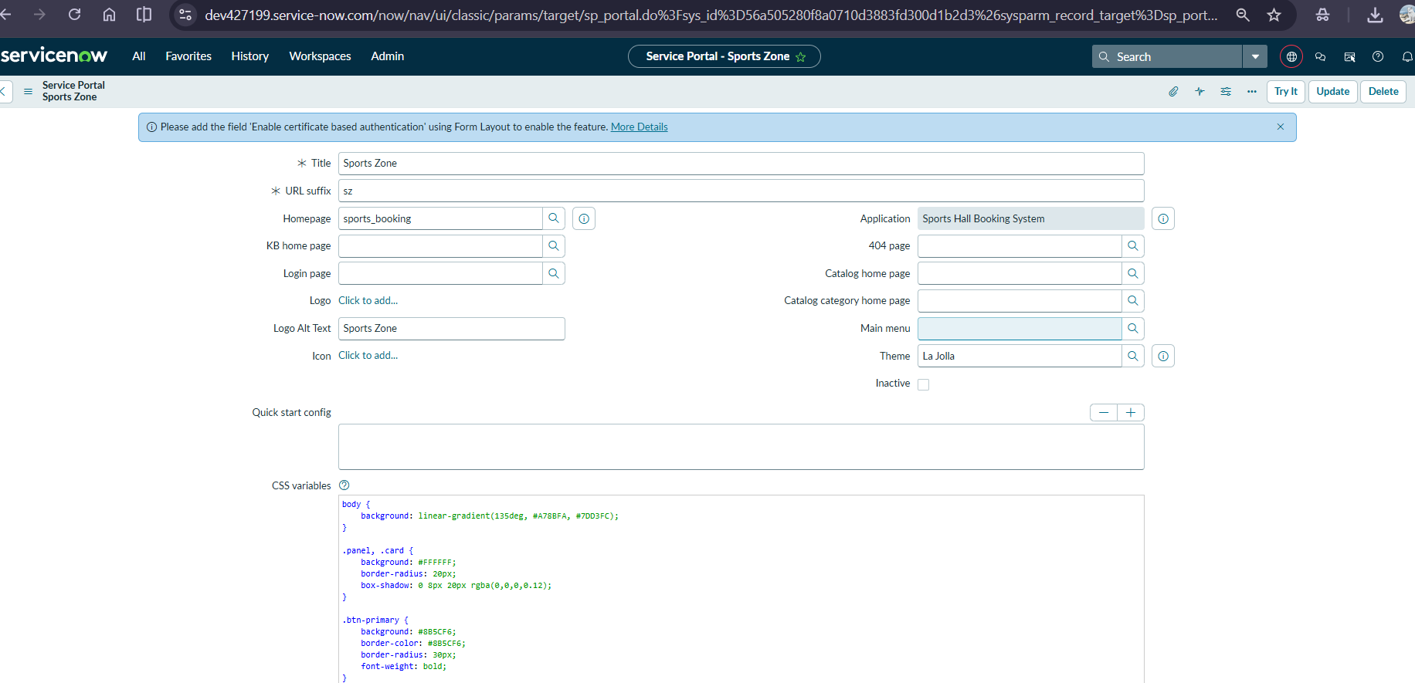

Event Registry

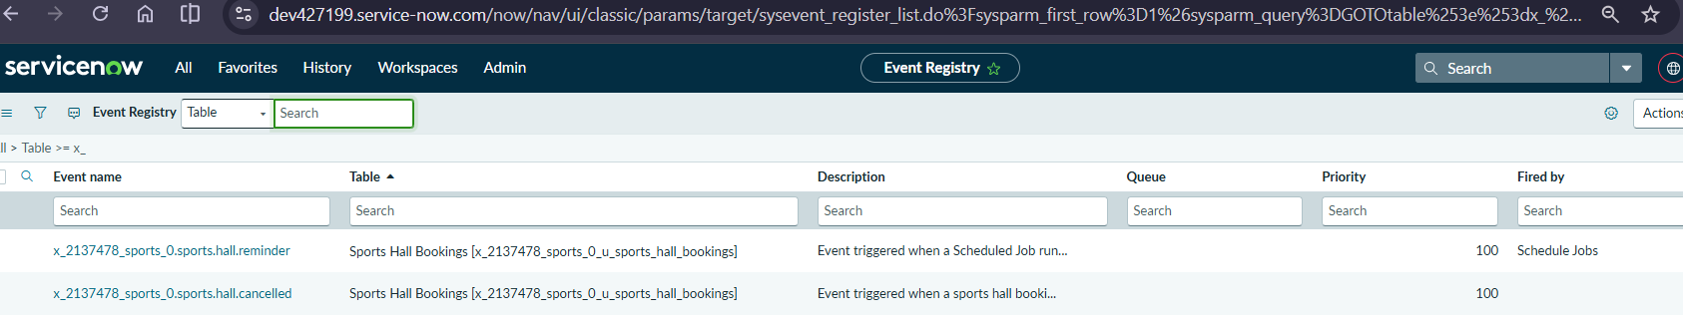
Notifications

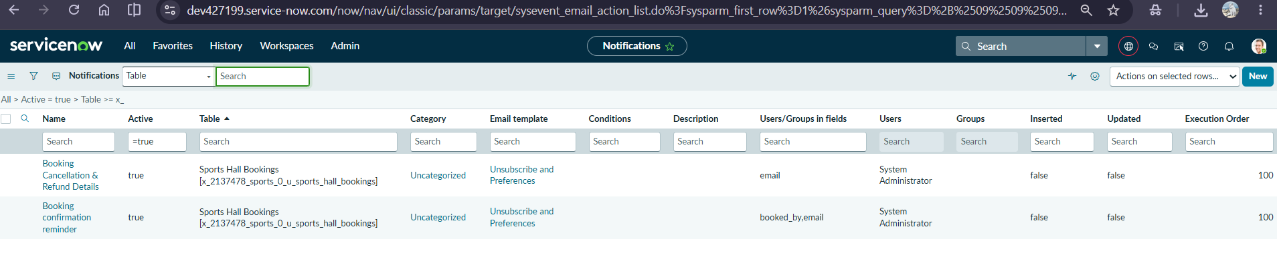

Events
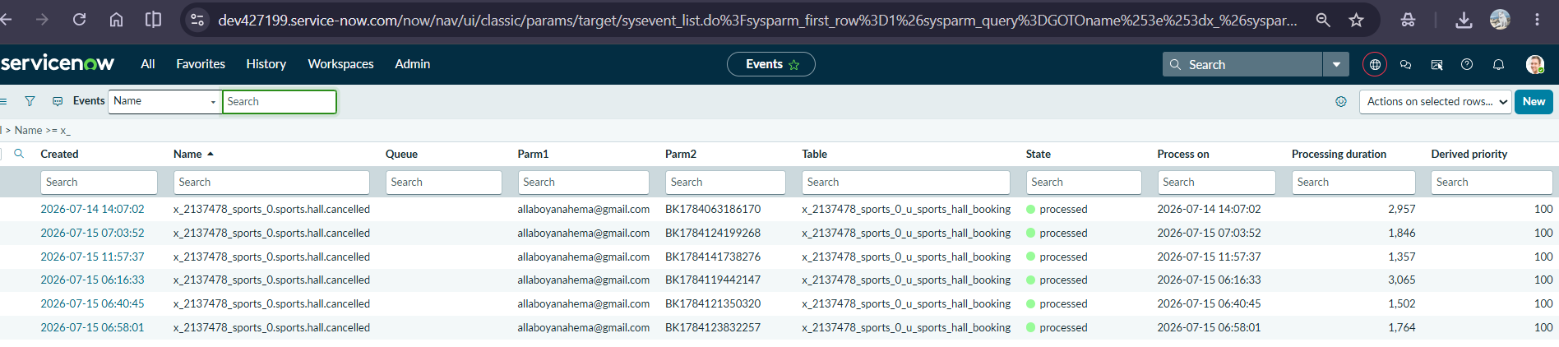
Emails-OutBox
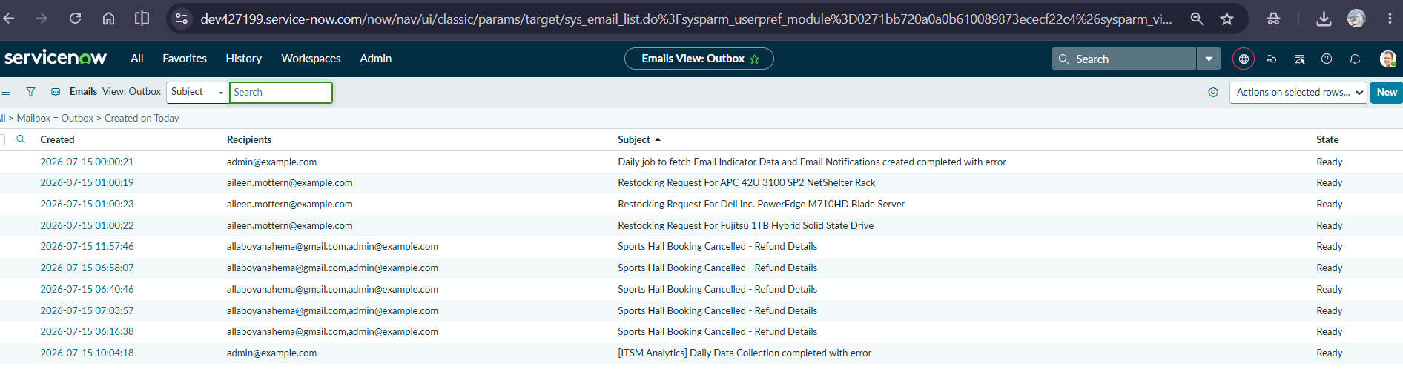

Module 1 – Home Page
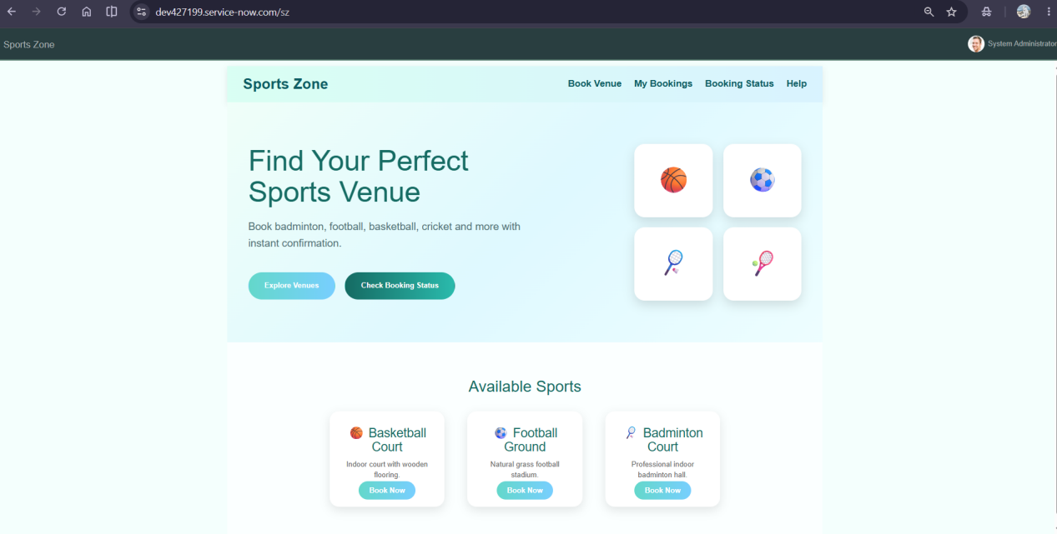

Module 2 – Booking Form
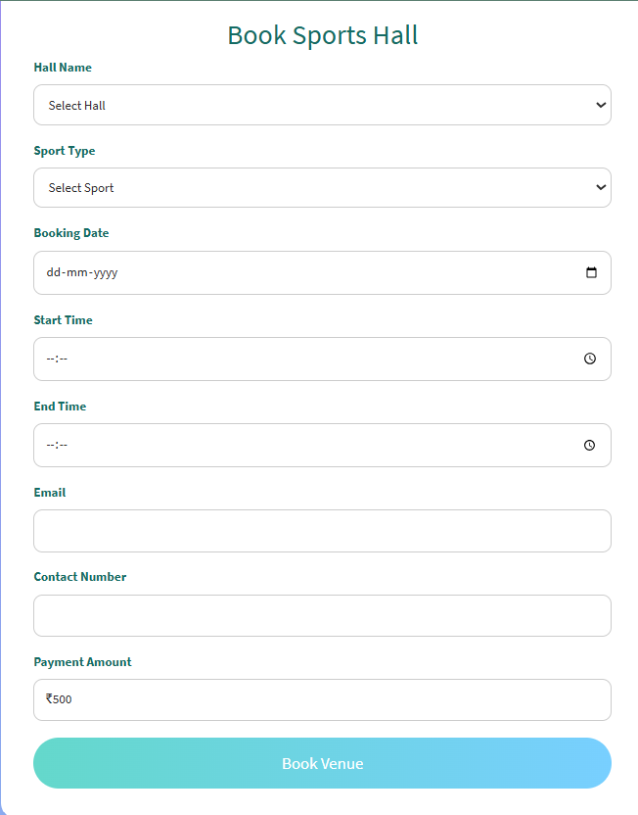

Module 3 – Payment Page
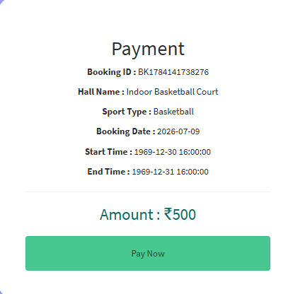
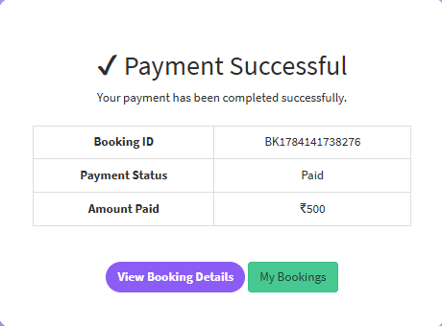
Module 4 – Booking Confirmation
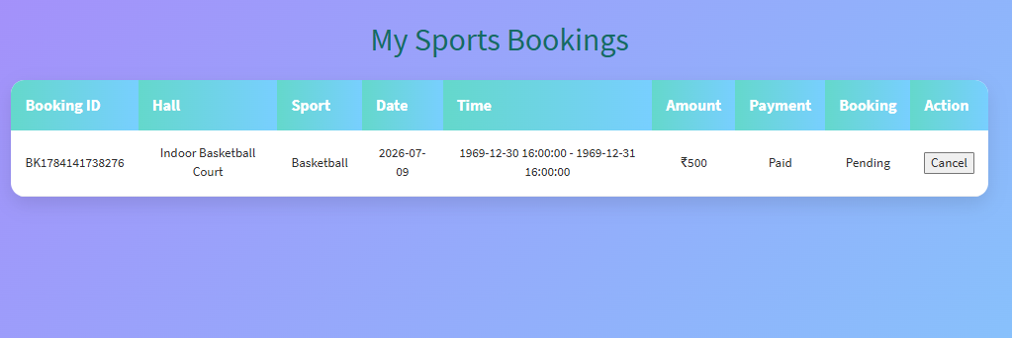

Module 5 – Booking Status
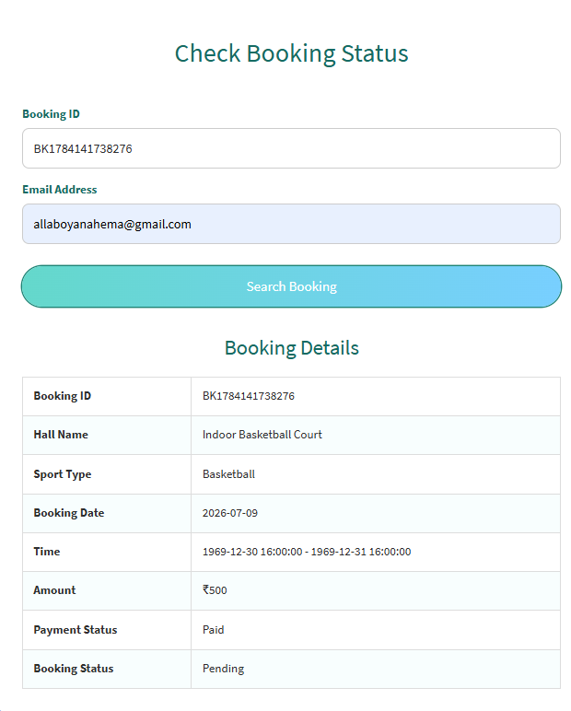

Module 6 - Cancel Booking Form
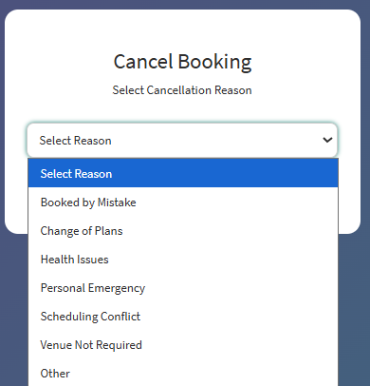

Module 7-Refund details
Cancellation Charges 10%
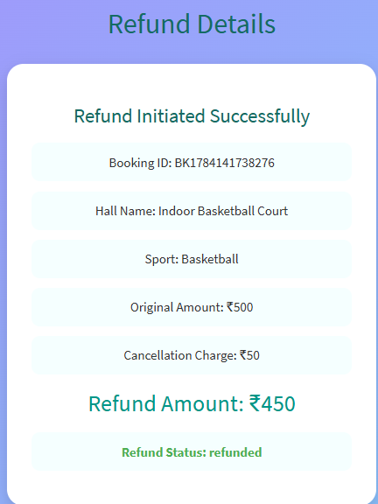

6. Conclusion
The Sports Hall Booking System was successfully designed and implemented using the ServiceNow Service Portal. The project delivers a centralized, secure, and user-friendly platform for sports hall reservations. By integrating automation, notifications, validation, and reporting, the system enhances the overall booking experience for users while simplifying administration and improving resource utilization.

